## **Output Analysis – /country REST Endpoint**

### Execution Flow

1. Browser or Postman sends GET request  
    URL: http://localhost:8083/country
2. Spring Boot controller method getCountryIndia() is invoked  
   * A new ApplicationContext is created from country.xml
   * Spring loads the bean with ID "country" (India)
   * The Country object is returned from the method
3. Spring uses Jackson to convert the Java object to JSON  
   * The Country object (code: IN, name: India) is serialized
4. HTTP response is sent back with JSON and status 200 OK

**Output:**

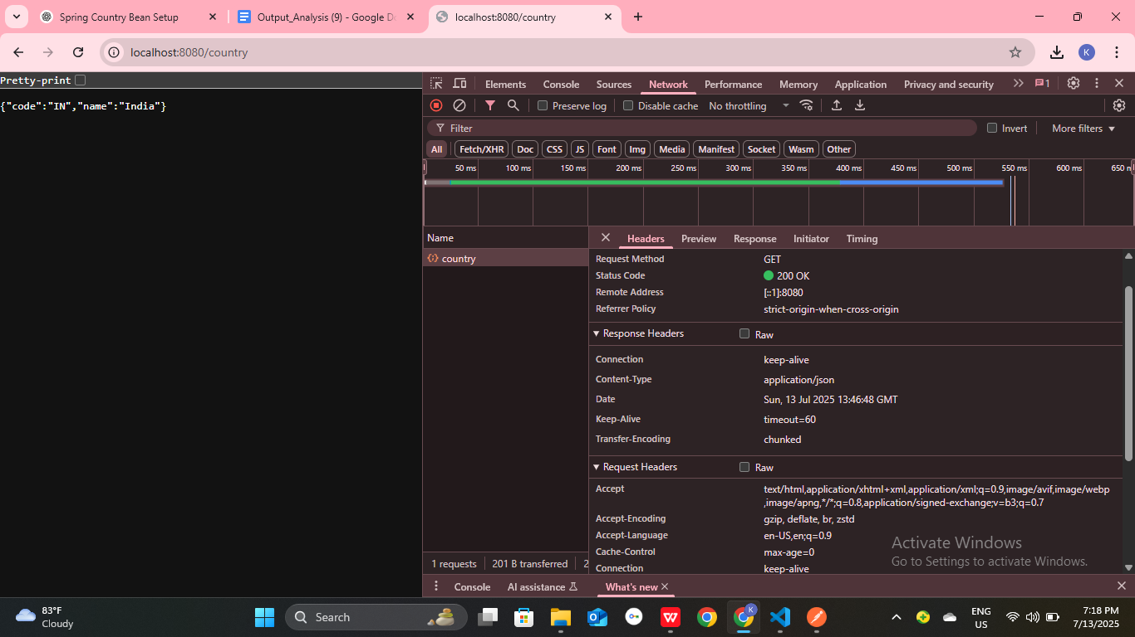

**Output:**

